HEALTH MONITORING & LOCATION TRACKING SYSTEM FOR SOLDIERS
Project Report
Submitted to
Dr. A.P.J. Abdul Kalam Technical University, Lucknow


In partial fulfillment for the award of the degree of
B. Tech.
in
Electronics and Communication Engineering

Submitted by

AMBIKA 2002220310004
RAHUL RAJ 2002220310016
RAJU KUMAR 2002220310017

Under the Supervision of
Asst. Prof. Mr. Agha A. Hussain

I. T. S ENGINEERING COLLEGE,
46, KNOWLEDGE PARK-III, GREATER NOIDA, U. P. (INDIA)
2020 – 2024

I.T.S Engineering College, Greater Noida

Certificate

This is to certify that AMBIKA Roll no -2002220310004 has carried out the project work presented in this report entitled “HEALTH MONITORING & LOCATION TRACKING SYSTEM FOR SOLDIERS” for the award of Bachelor of Technology in the stream of Electronics and Communication Engineering from Dr. A.P.J. Abdul Kalam Technical University, Lucknow under the supervision of Asst. Prof. Agha Asim Hussain. The thesis embodies results of work, and studies are carried out by the student herself and it is an authentic report.

Mr. Agha A Hussain Prof . Dr. A AmbikaPathy
(Asst. Prof) (Professor and Head – ECE)

I.T.S Engineering College, Greater Noida
Certificate

This is to certify that Rahul Raj Roll no -2002220310016 has carried out the project work presented in this report entitled “HEALTH MONITORING & LOCATION TRACKING SYSTEM FOR SOLDIERS” for the award of Bachelor of Technology in the stream of Electronics and Communication Engineering from Dr. A.P.J. Abdul Kalam Technical University, Lucknow under the supervision of Asst. Prof. Agha Asim Hussain. The thesis embodies results of work, and studies are carried out by the student himself and it is an authentic report.

Mr. Agha A Hussain Prof . Dr. A AmbikaPathy
(Asst. Prof) (Professor and Head – ECE)
I.T.S Engineering College, Greater Noida
Certificate

This is to certify that Raju Kumar Roll no -2002220310017 has carried out the project work presented in this report entitled “HEALTH MONITORING & LOCATION TRACKING SYSTEM FOR SOLDIERS” for the award of Bachelor of Technology in the stream of Electronics and Communication Engineering from Dr. A.P.J. Abdul Kalam Technical University, Lucknow under the supervision of Asst. Prof. Agha Asim Hussain. The thesis embodies results of work, and studies are carried out by the student himself and it is an authentic report.

Mr. Agha A Hussain Prof . Dr. A AmbikaPathy
(Asst. Prof) (Professor and Head – ECE)
Abstract
An Internet of Things (IoT) approach to Soldier Health Monitoring and Position Tracking is proposed, aiming to bolster soldier safety and mission success. This system leverages ESP32 CAM modules, which integrate a camera with health sensors, to capture soldiers' surroundings alongside real-time health vitals (temperature, heart rate) and GPS location data.
The system operates through three interconnected nodes: soldier node, squadron leader node, and control unit node. Soldier and squadron leader nodes utilize ESP32 CAM modules for environmental monitoring and health data collection. This collected data is then transmitted to the control unit using designated radio frequency modules, enabling short-range communication via HC-12 and long-range communication via SX1278.
The control unit acts as the central hub, receiving soldier and squadron leader data. It not only monitors the data for anomalies and stores it, but also offers offline visualization through an LCD for immediate analysis. Additionally, the control unit can leverage an IoT platform to display real-time soldier data over the internet, providing remote access to critical information.
This system offers significant value in defense forces and for civilians working in remote areas. By enabling real-time health monitoring and environmental data capture, it enhances soldier safety and facilitates search and rescue operations. Furthermore, the system contributes to mission efficiency by providing vital data for informed decision-making.

Acknowledgements
I have made valiant efforts in completing this project. However, it would not have been possible without the kind support and help of many individuals. I would like to extend my sincere thanks to all of them.
I am highly indebted to all the faculty members of Electronics and Communication Engineering Department who have directly or indirectly provided us their guidance and constant supervision as well as provided all the necessary information regarding the project and also for their support in the successful completion of the project.
I would like to express my gratitude towards my parents and Mr. Agha Asim Hussain for their kind co-operation and encouragement which help me in completion of this project.
My thanks and appreciations also go to my entire colleagues in developing the project and people who have willingly helped me out with their abilities.
1.AMBIKA
2. RAHUL RAJ
3. RAJU KUMAR

Table of Contents
List of Tables

List of Figures

List of Symbols and Abbreviations

CHAPTER 1:

INTRODUCTION
In today’s world, warfare is an important factor in any nation’s security. One of the important and vital roles is played by the army soldiers. There are many concerns regarding the safety of soldiers. So far their security purpose, many instruments are mounted on them to view their health status as well as their real time location. Bio-sensor systems comprise various types of small physiological sensors, transmission modules and processing capabilities, and can thus facilitate low-cost wearable unobtrusive solutions for health problem monitoring.
Traditional methods of health monitoring often fall short in providing real-time insights into the physiological and psychological conditions of military personnel. To address this challenge, the integration of Smart Health Monitoring Systems (SHMS) has emerged as a transformative approach, leveraging cutting-edge technologies to enhance the healthcare support for soldiers.
Smart Health Monitoring Systems, powered by Machine Learning (ML) algorithms, have shown promising results in revolutionizing the way we monitor, analyse, and respond to the health needs of military personnel. These systems not only offer continuous, non-intrusive monitoring but also possess the capability to predict and prevent potential health issues, thereby improving the overall readiness and effectiveness of the armed forces.
This comprehensive review aims to explore the latest developments in smart health monitoring technologies tailored specifically for soldiers. We delve into the integration of ML algorithms in monitoring various physiological parameters such as heart rate, body temperature, sleep patterns, and stress levels, real time location and movement tracking. Furthermore, we analyse the incorporation of advanced sensor technologies, wearable devices, and Internet of Things (IoT) solutions that form the backbone of these systems, providing a holistic and real-time picture of the soldier's health status.
The paper also addresses the challenges and ethical considerations associated with implementing smart health monitoring systems in military contexts. Privacy concerns, data security, and the seamless integration of these technologies into the existing military infrastructure are critical aspects that demand thorough exploration.
As we embark on this review journey, it becomes evident that the synergy between smart health monitoring systems and machine learning holds immense potential to revolutionize military healthcare. By enhancing the early detection of health issues, optimizing treatment strategies, and promoting proactive wellness, these systems contribute significantly to the overarching goal of ensuring the health and resilience of our armed forces.
In the subsequent sections, we delve into the key components of smart health monitoring systems, the machine learning algorithms driving their functionalities, and the potential impact on military operations. Through this exploration, we aim to provide a comprehensive understanding of the current state-of-the-art, challenges, and future prospects in the realm of smart health monitoring for soldiers.
This system helps to monitor health parameters of soldier, track their position, detect nearby bombs and predict the warzone environment using various sensors and K-Means machine learning algorithm.
The system helps the soldier to get help from army control unit and/or from another fellow soldier in panic situation. It will prove to be very useful to military forces during war and rescue operations as it can be used without any network restriction combining the capabilities of ZigBee and LoRaWAN.
Thus, this system provides security and safety to our soldiers. The proposed work can be expanded in the future in many directions.
The problem under study consists of improvement in health care system using cloud. We passionately dedicated to help medical fraternity to find health status of vital organs of the patient's body at early stage that support effective treatment by introducing innovative and high-quality hand carried non-invasive health care systems and devices.

Cloud based Health Care is the integration of cloud computing and health monitoring. The computing device enables the delivery of accurate medical information anytime anywhere by means of internet. Cloud based healthcare system consists of a computing device and number of sensors mounted on patient's body.

In this paper we present a Cloud based Intelligent Healthcare Monitoring System (CIHMS).

In general, IoT based health care platform which connects with smart sensors attach with human body for health monitoring for daily check-up. In project work we discussed about IoT based integrated patient health monitoring system.

The system technologies being used by smart phones or gadgets in present time where we also mentioned about advantages, challenges and opportunities. Due to the importance of observing medical patient, continuous remote monitoring is necessary. Our project work is giving the opportunity to monitor patient continuously by using the web and apps service along with live monitor and mobile message service. This paper also compared the early aged medical system between present time health monitoring.

The present time represents the time reducing; reduce health care cost especially for rural area people. The subsequent development of the project is extremely crucial in order to make the system more advanced and useful. In the designed system the improvement or amplification would be linking more sensors to internet which assess various other health parameters and would be advantageous for patient monitoring i.e. linking all the sensors to internet for swift and effortless access to establish a Wi-Fi mesh type network to increase in the Communication range.

Think Speak has been proposed to be used as the IoT-based Cloud Platform for the prototype model. It offers free data storage and analysis of time-stamped numeric or alphanumeric data.

Thing Speak library enables an Arduino or other compatible hardware to write or read data to or from Thing Speak. It is an open data platform for the Internet of Things (IoT) with MATLAB analytics and data visualization. It enables sensors, instruments, and websites to send data to the cloud where it is stored in either a private or a public channel.

Data is stored in private channels by default, but public channels can be used to share data with others. Once our data is collected or uploaded in a Thing Speak channel, it can be analysed, visualized and shared on social media, web services, and other devices.

MOTIVATION

The motivation for exploring the future scope of the Health and Movement Monitoring System for Soldiers is rooted in the pressing need to enhance the safety, efficiency, and effectiveness of military operations in increasingly complex and challenging environments. As modern warfare evolves, so do the demands placed on soldiers and the technology they rely upon. Here are the key motivations for each future scope:
- Integration with Wearable Technology Trends:
  - Motivation: The rapid advancement in wearable technology offers an opportunity to provide soldiers with cutting-edge tools that can monitor a wider range of health metrics. By integrating the latest sensors, we can ensure that soldiers receive real-time, comprehensive health assessments, thereby improving their well-being and operational readiness.
- Enhanced Data Analytics and Predictive Insights:
  - Motivation: Leveraging sophisticated data analytics and machine learning algorithms can transform raw data into actionable insights. Predictive modeling can foresee health issues and optimize operational strategies, ultimately leading to more informed decision-making and proactive measures to ensure soldier safety.
- Augmented Reality (AR) Interfaces:
  - Motivation: AR interfaces can significantly enhance situational awareness by providing soldiers with real-time, contextually relevant information directly in their field of view. This technology can facilitate faster decision-making and improve the coordination and execution of military operations.
- Bi-directional Communication and Command Support:
  - Motivation: Enhancing communication capabilities to support two-way interactions between soldiers and command units can improve operational coordination and responsiveness. This ensures that soldiers receive timely instructions and can relay critical information back to the command, thus enhancing mission success and safety.
- Environmental Adaptability and Durability:
  - Motivation: Military operations often occur in harsh and unpredictable environments. Developing a monitoring system that is resilient to extreme conditions ensures that soldiers can rely on their equipment regardless of the operational terrain, thus maintaining continuous monitoring and communication.
- Interoperability with Existing Military Systems:
  - Motivation: Ensuring that the monitoring system can seamlessly integrate with existing military infrastructure enhances its utility and adoption. Interoperability reduces redundancy, leverages existing technologies, and ensures smooth operational workflows, thereby optimizing resource utilization and mission planning.
- Cybersecurity and Data Privacy:
  - Motivation: In an era where cyber threats are increasingly sophisticated, robust cybersecurity measures are crucial to protect sensitive military data. Ensuring the security and privacy of health and location data safeguards against potential breaches that could compromise soldier safety and mission integrity.
- Scalability and Modular Design:
  - Motivation: A scalable and modular design allows the system to evolve with technological advancements and changing military needs. This flexibility ensures that the system remains relevant and effective over time, accommodating new functionalities and expanding its capabilities as required.
- User Experience Optimization:
  - Motivation: A user-friendly interface enhances the acceptance and effective use of the monitoring system. By continuously improving the user experience based on feedback, the system becomes more intuitive and easier to use, thereby ensuring that soldiers and commanders can fully leverage its capabilities with minimal training.
- Cross-Domain Applications and Civilian Use Cases:
  - Motivation: Exploring applications beyond military contexts, such as in emergency response and healthcare, can extend the benefits of the monitoring system to civilian domains. This not only broadens the impact of the technology but also fosters innovation and collaboration across different sectors.

Chapter 2

2.1 LITERATURE REVIEW

This paper presents a prototype for an automatic health monitoring system that continuously tracks various health parameters and predicts potential diseases or disorders, thereby reducing the need for frequent hospital visits. The system, designed for hospital use, gathers and stores large amounts of data in an online database, accessible via a mobile application. Enhancements could include integrating artificial intelligence components to assist both doctors and patients. By applying data mining techniques to the amassed medical history and health parameters, the system can identify consistent patterns and systematic relationships, aiding in disease prediction and management. For example, if a patient's health parameters mirror those of previous patients, the system can predict potential outcomes, assisting medical professionals in finding remedies.
This health monitoring system is particularly useful in emergency conditions, where continuous monitoring and data recording are crucial. The integration of IoT devices with cloud computing could facilitate data sharing across intensive care units and treatment hospitals, proving invaluable during pandemics by enabling remote health monitoring, thus minimizing hospital visits.
The primary goal of the work is to detect motion distortions in blood pressure (BP) and photoplethysmogram (PPG) signals using algorithms tested on a publicly available ICU database and various patient groups. The study found that the Adobos Regressor, based on decision tree algorithms, excelled in estimating BP values. The proposed model’s approach using a single PPG signal and probe demonstrated high accuracy in measuring systolic and diastolic BP, offering a discreet and effective method for long-term in-home care. However, the study highlights the need for further research to validate the algorithm's efficacy across diverse patient populations, including obese and arrhythmia patients. Despite its promising results, the PPG algorithm's limited testing on a small sample of elderly arrhythmia patients indicates the necessity for broader studies to ensure its reliability and accuracy across different health conditions.

Chapter 3

3.1 METHODOLOGY

The proposed methodology includes several key components:
3.1.1. Hardware Integration: The selection of essential components such as the Arduino MEGA 2560, bio-sensors, GPS modules, ZigBee, and LoRaWAN modules plays a critical role in the development of advanced wearable systems for soldiers. Ensuring these components are compatible and maintain the wearability of the equipment is paramount for enhancing soldier mobility and operational effectiveness.
The Arduino MEGA 2560 is chosen for its robust processing capabilities and extensive I/O options, making it suitable for handling multiple sensors and communication modules simultaneously. Its versatility and large memory capacity ensure that it can manage complex data from various inputs without compromising performance.
Bio-sensors are essential for monitoring soldiers' vital signs, such as heart rate, body temperature, and respiratory rate. These sensors provide real-time health data, enabling continuous assessment of soldiers' physical conditions and immediate response to any medical emergencies. Integrating these sensors with the Arduino MEGA 2560 allows for efficient data processing and storage.
GPS modules are incorporated to provide precise geographic location data, including latitude, longitude, altitude, and time information. This capability is crucial for navigation, mission planning, and real-time tracking of soldiers in the field. The integration of GPS with the Arduino MEGA 2560 ensures seamless data acquisition and processing.
LoRaWAN modules are included for their long-range, low-power communication capabilities, ideal for transmitting data over extended distances. This technology ensures that soldiers can maintain communication with the central command or distant base stations, even in remote or challenging terrains. The Arduino MEGA 2560 can handle the integration of LoRaWAN, providing a seamless interface for long-range data transmission.
Ensuring compatibility among these components is vital. The Arduino MEGA 2560’s extensive libraries and support for various sensors and communication modules facilitate this integration. Proper interfacing and synchronization are necessary to ensure that data from bio-sensors, GPS, ZigBee, and LoRaWAN modules are accurately collected, processed, and transmitted.
Wearability is another crucial factor. All components need to be compact, lightweight, and durable to withstand harsh field conditions. They should be ergonomically designed to minimize any hindrance to the soldiers' movements. Flexible circuits, lightweight enclosures, and efficient power management systems are employed to enhance the wearability of the devices.
3.1.2. Communication Framework: Developing a robust framework for data transmission using LoRaWAN involves several key steps, ensuring reliability and efficiency while excluding less dependable methods like GSM and RF. LoRaWAN is particularly well-suited for this purpose due to its long-range, low-power capabilities and strong resilience to interference.
- Network Architecture Design: Begin by designing a network architecture that maximizes coverage and efficiency. This involves strategically placing LoRaWAN gateways to ensure seamless coverage over the desired area. Gateways should be positioned to optimize signal strength and minimize dead zones, considering factors like terrain and building density.

- Device Configuration: Configure the end devices (nodes) equipped with LoRaWAN modules to ensure optimal data transmission. This includes setting appropriate data rates and transmission power levels to balance range and battery life. Devices should also be programmed to transmit data at intervals that align with the application's needs, avoiding unnecessary data traffic.

- Gateway Setup: Deploy robust gateways with reliable internet backhaul to connect the LoRaWAN network to the central server. Gateways should support high packet forward rates and have sufficient processing power to handle multiple simultaneous connections. They must also be equipped with secure connections to prevent unauthorized access.

- Network Server Implementation: Implement a network server that manages the LoRaWAN infrastructure. The server handles tasks such as device registration, session management, and data routing. It ensures that data packets from end devices are correctly received, processed, and forwarded to the application server.

- Application Server Integration: Develop an application server that processes and analyzes the data received from the network server. This server should be capable of handling large volumes of data and providing real-time analytics and alerts based on the transmitted data. It also interfaces with user applications, providing a dashboard or API for data access.

- Data Security: Ensure robust data security measures are in place throughout the framework. LoRaWAN includes built-in encryption (AES-128) for secure data transmission, but additional layers of security, such as SSL/TLS for data transfer between gateways and network servers, should be implemented to protect against potential threats.

- Scalability and Redundancy: Design the system to be scalable and redundant. As the number of devices and data volume grow, the network should be able to scale without degradation in performance. Redundancy in gateways and servers ensures that the network remains operational even if some components fail.

- Energy Efficiency: Optimize energy consumption for battery-powered devices. LoRaWAN’s low-power characteristics are advantageous, but further optimizations can be achieved through adaptive data rate (ADR) settings, sleep modes, and efficient power management strategies.

- Monitoring and Maintenance: Implement comprehensive monitoring tools to track network performance, device status, and data integrity. Regular maintenance schedules and firmware updates are essential to keep the system running smoothly and securely.

- Excluding Unreliable Methods: Explicitly avoid using GSM and traditional RF methods due to their limitations in reliability, range, and power consumption. GSM networks are dependent on cellular infrastructure, which can be inconsistent in remote areas, while RF methods often suffer from higher interference and lower data integrity.

3.1.3. Data Transmission and Cloud Integration: Implementing secure data transmission systems and utilizing cloud-based storage for centralized data access and analysis involves several critical steps to ensure data integrity, confidentiality, and availability. This approach leverages the strengths of secure communication protocols and cloud infrastructure to create a robust, scalable, and secure data management framework.
- Secure Data Transmission: Employ end-to-end encryption for data transmission. Use strong encryption protocols like AES-128 or AES-256 to ensure that data remains confidential as it travels from end devices to the cloud. Implement secure communication channels using protocols such as HTTPS, SSL/TLS, and VPNs to protect data from interception and tampering.

- Device Authentication: Ensure that only authorized devices can connect to the network by using secure authentication mechanisms such as mutual authentication, digital certificates, and token-based authentication. This prevents unauthorized devices from accessing or disrupting the network.

- LoRaWAN Security Features: Utilize LoRaWAN's built-in security features, including unique network session keys (NwkSKey) and application session keys (AppSKey) for each device. These keys ensure secure communication and data encryption between devices and the network server.

- Data Integrity Checks: Implement data integrity checks using hashing algorithms (e.g., SHA-256) to ensure that data has not been altered during transmission. This provides an additional layer of security, verifying that the data received is the same as the data sent.

- Cloud-Based Storage: Use cloud storage solutions (such as AWS, Google Cloud, or Azure) to centralize data access and analysis. Cloud platforms offer scalable storage, high availability, and robust security features, ensuring that data is accessible and secure.

- Access Control: Implement strict access control policies to restrict data access to authorized users only. Use role-based access control (RBAC) and multi-factor authentication (MFA) to enhance security and prevent unauthorized access to sensitive data.

- Data Encryption at Rest: Encrypt data stored in the cloud to protect it from unauthorized access. Use cloud provider encryption services or manage your own encryption keys to ensure that data remains encrypted at rest.

- Scalable Data Processing: Utilize cloud-based data processing tools and services, such as AWS Lambda, Google Cloud Functions, or Azure Functions, to process and analyze data in real-time. These tools enable scalable, on-demand data processing without the need for dedicated infrastructure.

- Centralized Data Management: Implement a centralized data management system to streamline data access and analysis. Use cloud databases and data lakes to aggregate and manage data from multiple sources, providing a single point of access for data analysis.

- Data Analytics and Visualization: Integrate data analytics and visualization tools with your cloud storage to analyze and visualize data. These tools provide insights and actionable intelligence, helping stakeholders make informed decisions.

- Regular Audits and Compliance: Conduct regular security audits and ensure compliance with relevant data protection regulations. This helps identify and mitigate potential security risks and ensures that data handling practices meet regulatory requirements.

- Backup and Disaster Recovery: Implement robust backup and disaster recovery plans to ensure data availability and integrity in case of system failures or cyber-attacks. Use cloud provider backup services to create regular backups and store them securely.

- Monitoring and Alerts: Use cloud monitoring tools to continuously monitor the system for unusual activities or potential security breaches. Set up alerts to notify administrators of any suspicious behavior or system anomalies.

3.1.4. Data Analysis and Prediction: Employing the K-Means Clustering algorithm involves categorizing health metrics and location information into distinct, actionable clusters such as healthy, ill, abnormal, and deceased. K-Means works by partitioning the data into kkk clusters, where each data point belongs to the cluster with the nearest mean. In this context, health metrics (e.g., heart rate, temperature) and location data are collected from sensors. These data points are then processed by K-Means to identify patterns and group similar health statuses together.
For instance, data points with normal vital signs might cluster as "healthy," while those with irregular metrics could be grouped as "ill" or "abnormal." Additionally, location information can help distinguish whether an individual is stationary or moving, adding context to their health status. The result is a set of clusters that provide actionable insights for monitoring and responding to health conditions in real time.

3.1.5. Usability and User Interface: Designing user-friendly interfaces for soldiers, squad leaders, and control unit personnel requires a focus on simplicity, intuitiveness, and efficiency to ensure ease of use and minimize training requirements. The interfaces should be tailored to meet the specific needs and contexts of each user group, ensuring that vital information is accessible and actionable in real-time.
- Soldier Interface:
  - Wearable Display: Use heads-up displays (HUDs) or smartwatches that provide real-time health metrics, GPS location, and basic alerts.
  - Simplified Controls: Implement single-button operations or voice commands for ease of use under stress.
  - Icon-Based Navigation: Use intuitive, universally understood icons to represent different functions and alerts.
- Squad Leader Interface:
  - Tablet or Ruggedized Device: Equip squad leaders with tablets or ruggedized handheld devices that offer a larger screen for better data visualization.
  - Real-Time Dashboard: Provide a comprehensive dashboard displaying health statuses, locations of squad members, and mission-critical information.
  - Communication Tools: Integrate secure communication features for issuing commands and receiving reports seamlessly.

- Control Unit Interface:
  - Multi-Screen Workstations: Set up workstations with multiple screens to monitor extensive data streams from various units.
  - Advanced Data Visualization: Use graphical representations such as maps, charts, and heatmaps to display troop movements, health metrics, and environmental conditions.
  - Analytical Tools: Incorporate tools for data analysis and decision-making support, allowing control unit personnel to quickly interpret information and coordinate responses.

- Common Features:
  - Customizable Alerts: Allow users to set and customize alerts for different parameters such as heart rate anomalies, critical location changes, or mission updates.
  - User-Friendly Interface: Ensure a consistent and intuitive design language across all devices to minimize confusion and training time.
  - Offline Capability: Design interfaces that can function with limited connectivity, ensuring critical information remains accessible even in communication blackouts.

- Training and Support:
  - Interactive Tutorials: Provide interactive, scenario-based tutorials embedded within the devices to help users learn through practice.
  - User Manuals: Develop concise and clear user manuals with step-by-step instructions and visual aids.
  - Help and Support: Implement an in-device help feature that offers quick assistance and troubleshooting guidance.

- Feedback Mechanism:
  - User Feedback Integration: Continuously collect feedback from soldiers, squad leaders, and control unit personnel to refine and improve the interfaces.
  - Regular Updates: Ensure the software is regularly updated to address any usability issues and incorporate new features based on user feedback.

3.1.6. Environmental Adaptability: Addressing environmental challenges in high altitudes and adverse weather conditions requires rugged hardware and robust communication protocols to ensure reliable operation. Rugged hardware, such as waterproof, dustproof, and shock-resistant devices, ensures durability and continuous functionality in harsh environments. Components must withstand extreme temperatures, humidity, and physical impacts.
Robust communication protocols, like LoRaWAN and ZigBee, are essential for maintaining connectivity despite environmental obstacles. These protocols provide long-range, low-power, and interference-resistant communication, ensuring data transmission remains reliable even in remote or challenging terrains. Additionally, redundancy measures, such as mesh networking and multiple gateway deployments, enhance system resilience and mitigate the impact of communication disruptions, ensuring consistent and reliable performance in all conditions.

3.1.7. Security and Privacy: Implementing robust security measures to protect sensitive data and comply with privacy regulations involves several key strategies. These include:
- Data Encryption: Encrypting data both in transit and at rest using strong encryption algorithms to prevent unauthorized access.

- Access Control: Implementing strict access controls and authentication mechanisms to ensure that only authorized users can access sensitive information.

- Regular Audits: Conducting regular security audits and assessments to identify vulnerabilities and ensure compliance with privacy regulations.

- Data Masking and Anonymization: Masking or anonymizing sensitive data to protect individual privacy while still allowing for analysis and processing.

- Secure Data Storage: Storing data in secure, encrypted databases or cloud storage solutions with built-in security features to prevent data breaches.

- Employee Training: Providing comprehensive training to employees on security best practices and privacy regulations to prevent data leaks or breaches due to human error.

- Incident Response Plan: Developing and regularly updating an incident response plan to quickly respond to and mitigate any security incidents or breaches.

- Third-party Security Assessment: Conducting thorough security assessments of third-party vendors and service providers to ensure they meet security and privacy standards.

- Data Minimization: Minimizing the collection and retention of sensitive data to reduce the risk of data breaches and comply with privacy regulations.
- Compliance Monitoring: Monitoring regulatory changes and updating security measures accordingly to ensure ongoing compliance with privacy regulations.

Chapter 4

4.1 EXPERIMENTAL RESULTS

4.1.1. System Setup

The proposed health monitoring system was tested with the following hardware and software setup:

4.1.1.1. Hardware Components:

- Arduino MEGA 2560 microcontroller
- Bio-sensors for monitoring heart rate and temperature
- GPS module for location tracking
- ZigBee and LoRaWAN modules for communication
- ECG module
- Bomb detector
Details of Components:
1. Arduino MEGA 2560 Microcontroller
Details:
Microcontroller Specifications: The Arduino MEGA 2560 features an ATmega2560 processor with 54 digital input/output pins, 16 analog inputs, and 4 UARTs (hardware serial ports). It operates at 16 MHz with ample memory (256 KB of flash memory, 8 KB of SRAM, and 4 KB of EEPROM).
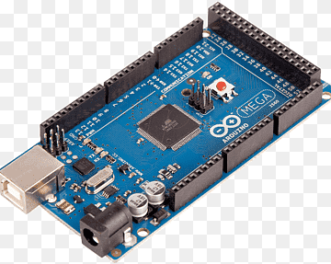
Programming: It is programmable through the Arduino IDE using a simple USB connection, making it accessible for developing and debugging the system’s firmware.
Integration: The microcontroller can interface with various sensors and modules (like bio-sensors, GPS, and LoRaWAN) to collect data, process it, and send it to the appropriate modules for communication and storage.

2. Bio-sensors for Monitoring Heart Rate and Temperature
Details:
Heart Rate Sensors: Typically, these sensors use photoplethysmography (PPG) to measure heart rate by detecting blood volume changes in the microvascular bed of tissue. They can be integrated into wearable devices such as wristbands.
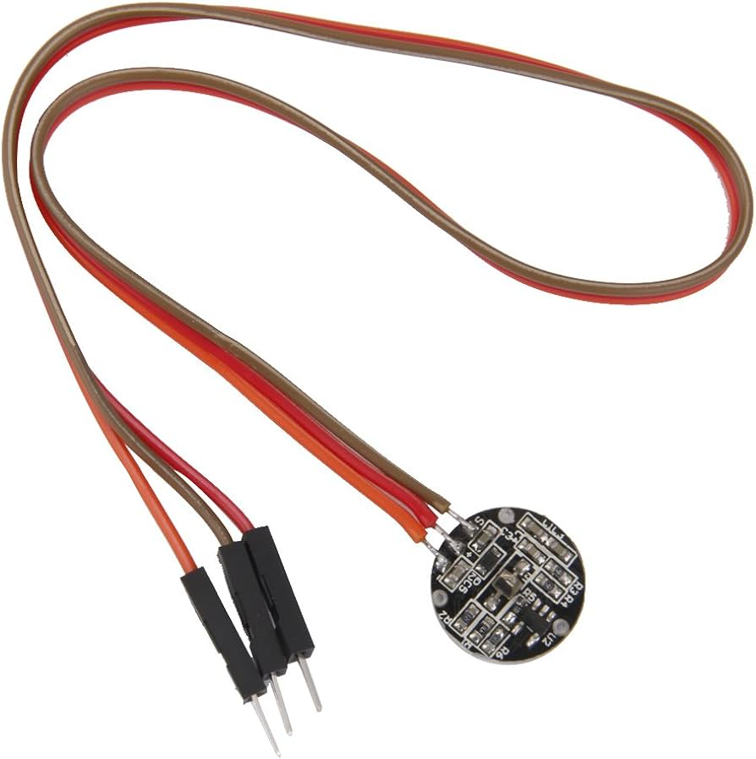
Temperature Sensors: These sensors measure body temperature using thermistors or infrared sensors. Accurate body temperature monitoring is crucial for detecting fever or hypothermia, which can indicate health issues or environmental exposure.
Wearability: Designed to be lightweight and unobtrusive, these sensors can be integrated into clothing or accessories worn by soldiers without impeding their movement or comfort.

3. GPS Module for Location Tracking
Details:
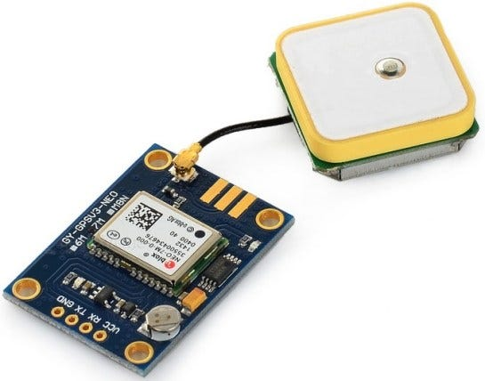
Functionality: GPS (Global Positioning System) modules are sophisticated devices designed to receive signals from a network of satellites to calculate precise geographic locations. These modules are essential in various applications, from navigation to tracking and beyond, providing critical data on latitude, longitude, altitude, and time.
A GPS module functions by locking onto signals from multiple satellites in the GPS constellation, which typically consists of at least 24 satellites orbiting the Earth. Each satellite transmits a unique signal that includes its position and the precise time the signal was sent. By receiving signals from at least four satellites, the GPS module can perform trilateration to determine the device's exact position on Earth.
The primary outputs of a GPS module include:
- Latitude and Longitude: These coordinates pinpoint the exact location on the Earth's surface, allowing users to determine their position with high accuracy.
- Altitude: This information indicates the height above sea level, which is crucial for applications such as aviation and mountain navigation.
- Time Information: GPS modules provide highly accurate time data, synchronized with atomic clocks on the satellites, which is vital for time-sensitive applications like telecommunications and network synchronization.
GPS modules are widely used in numerous fields. In everyday life, they power the navigation systems in cars, smartphones, and wearable devices, guiding users from one location to another with turn-by-turn directions. In logistics and transportation, GPS modules enable real-time tracking of vehicles, helping companies optimize routes, improve delivery times, and enhance fleet management.
In agriculture, GPS technology supports precision farming, allowing farmers to monitor and manage field conditions with high accuracy, thereby increasing efficiency and crop yields. Surveyors and geologists use GPS modules for accurate mapping and exploration, while outdoor enthusiasts rely on them for activities such as hiking, geocaching, and boating.
Moreover, GPS modules are critical in emergency response scenarios, enabling first responders to quickly locate individuals in distress and coordinate rescue operations more effectively. They also play a significant role in scientific research, such as tracking animal migration patterns, monitoring environmental changes, and conducting geological studies.
Advanced GPS modules often integrate additional features to enhance their functionality. For example, some modules include support for multiple satellite navigation systems like GLONASS (Russia), Galileo (Europe), and BeiDou (China), providing improved accuracy and reliability, especially in challenging environments like urban canyons or dense forests.
Furthermore, modern GPS modules can be combined with other sensors, such as accelerometers, gyroscopes, and magnetometers, to provide comprehensive navigation solutions that maintain accuracy even when satellite signals are temporarily unavailable. This integration is particularly useful in applications like autonomous vehicles, drones, and robotics.

Integration: The GPS module interfaces with the Arduino MEGA 2560 via serial communication. It continuously sends location data to the microcontroller, which processes and transmits this information to the command center.

Use Cases: Real-time tracking enables effective mission planning, coordination, and search-and-rescue operations by providing commanders with up-to-date information on soldiers' locations.

4. LoRaWAN Modules
LoRaWAN Modules: LoRaWAN (Long Range Wide Area Network) modules are specialized devices designed to facilitate long-range, low-power wireless communication for wide-area networks. These modules are particularly well-suited for applications requiring data transmission over vast distances, such as in rural or remote areas, without the need for significant infrastructure investment.
One of the primary advantages of LoRaWAN technology is its ability to achieve communication ranges of up to 15-30 kilometers in rural areas and 2-5 kilometers in urban environments, making it ideal for IoT (Internet of Things) applications. This long-range capability is coupled with low power consumption, allowing devices to operate on battery power for several years, which is crucial for deployments where frequent battery replacement is impractical.
LoRaWAN operates in the sub-gigahertz frequency bands (such as 868 MHz in Europe and 915 MHz in North America), which helps in achieving better penetration through obstacles like buildings and foliage. The protocol supports a star-of-stars topology, where end devices communicate directly with gateways, which then forward the data to a central network server.
These modules are often used in various sectors, including agriculture for monitoring crop conditions, smart cities for managing utilities and public services, industrial automation for tracking equipment, and logistics for asset tracking. For instance, in agriculture, sensors equipped with LoRaWAN modules can transmit soil moisture levels, temperature, and other environmental data to a central hub, allowing farmers to make informed decisions.
In military applications, LoRaWAN modules can be used for secure and efficient communication between squad leaders and base stations. The long-range capability ensures that messages and data can be relayed over significant distances without the need for a dense network of relay stations, which is particularly useful in vast and challenging terrains.
Furthermore, the LoRaWAN protocol includes built-in security features, such as end-to-end encryption and mutual authentication, ensuring that the data transmitted is secure and protected from unauthorized access. This makes LoRaWAN suitable for applications where data integrity and confidentiality are paramount.

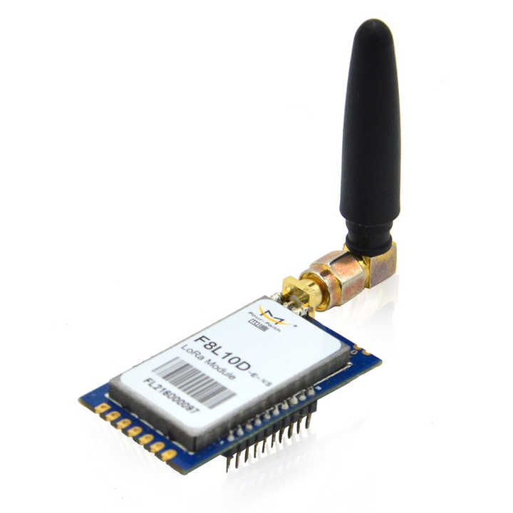
Specifications: Operates in various sub-gigahertz frequency bands (e.g., 868 MHz in Europe, 915 MHz in North America), supports data rates from 0.3 kbps to 50 kbps, and can cover distances up to 10-15 kilometers in rural areas.

Usage: Ensures that data collected from soldiers can be transmitted over large distances to command centers, even in remote or challenging environments.

4. ECG Module
Details:
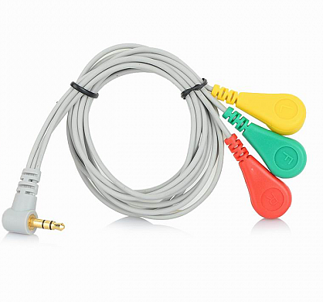
Functionality: The ECG (Electrocardiogram) module is a crucial medical device designed to detect and record the electrical signals generated by heartbeats. This module plays a vital role in monitoring heart health by capturing data on heart rhythm and rate, providing essential insights into the cardiovascular system's functionality.
An ECG module works by placing electrodes on the skin, typically on the chest, arms, and legs. These electrodes detect the tiny electrical changes on the skin that arise from the heart muscle's depolarization during each heartbeat. The signals are then amplified and recorded, producing a graphical representation of the heart's electrical activity over time, known as an ECG trace or waveform.
The data collected by the ECG module can be used to assess various aspects of heart health. One of the primary uses is to identify arrhythmias, which are irregular heartbeats. Arrhythmias can range from harmless variations to serious conditions that may require medical intervention. By analyzing the ECG waveform, healthcare providers can determine if the heart is beating too fast, too slow, or irregularly.
In addition to arrhythmias, the ECG module can help detect signs of a heart attack (myocardial infarction). During a heart attack, the blood supply to a part of the heart is blocked, leading to damage of the heart muscle. This damage often manifests as specific changes in the ECG waveform, such as ST segment elevation or T wave inversion, which can be quickly identified by trained medical personnel.
Beyond arrhythmias and heart attacks, the ECG module can also aid in diagnosing other cardiac issues such as atrial fibrillation, ventricular hypertrophy, and ischemic heart disease. It can also be used to monitor the effects of medications, the functioning of pacemakers, and the overall health of the heart over time.
Modern ECG modules are often integrated with advanced digital technologies, allowing for real-time data transmission to remote healthcare providers. This telemedicine capability is particularly valuable in emergency situations, where rapid diagnosis and treatment can be life-saving. Additionally, portable and wearable ECG devices enable continuous monitoring, providing valuable data over extended periods and enhancing patient convenience and compliance.
Furthermore, the integration of artificial intelligence (AI) and machine learning algorithms with ECG modules is revolutionizing cardiac care. These technologies can analyze vast amounts of ECG data to detect subtle patterns and anomalies that might be missed by human observers, leading to earlier and more accurate diagnosis of cardiac conditions.
Integration: Typically interfaced with the Arduino MEGA 2560 through analog inputs, the ECG module transmits continuous data to the microcontroller for processing and monitoring.
Usage: Used for real-time cardiac monitoring, providing critical data that can alert medical personnel to potential heart problems, ensuring timely medical intervention.

4.1.1.2. Software Tools:

- Arduino IDE for microcontroller firmware development
- LoRaWAN libraries for communication
- Blynk IOT

4..1.2. Data Collection

The system collected real-time data on soldiers' health parameters (heart rate, temperature, and ECG) and location. The data was transmitted to the squad leader using ZigBee and then to the base station via LoRaWAN. All collected data was stored in a cloud database for analysis and monitoring.
Key Metrics
The primary metrics for evaluating the system's performance were:
4.1.2.1. Accuracy of Health Monitoring: The accuracy of health monitoring systems is assessed by comparing their readings with those obtained from standard medical equipment, such as ECG machines, blood pressure monitors, and pulse oximeters. This comparison ensures that the measurements provided by the monitoring system are consistent and reliable. The accuracy evaluation involves statistical analysis to determine the level of agreement or discrepancy between the two sets of data. Additionally, validation studies are conducted to assess the system's performance across different population groups and health conditions. Continuous calibration and quality control measures are implemented to maintain the accuracy of the monitoring system over time and ensure its suitability for clinical use.
4.1.2.2. Reliability of Communication: The reliability of communication systems is evaluated by assessing the success rate of data transmission across various terrains and weather conditions. This assessment involves testing the system's performance in different environments, including urban, rural, mountainous, and maritime areas, as well as under adverse weather conditions such as heavy rain, snow, or strong winds. The success rate of data transmission, including packet delivery ratio and latency, is measured and analyzed to determine the system's reliability.
4.1.2.3. Data Analysis Efficiency: The accuracy and usefulness of the K-Means Clustering algorithm in categorizing health data are assessed based on several factors. These include the algorithm's ability to effectively group similar health metrics into meaningful clusters, such as healthy, ill, abnormal, and deceased. Evaluation metrics such as cluster purity, silhouette score, and intra-cluster cohesion are used to measure the quality of the clustering results. Additionally, the algorithm's scalability and computational efficiency are considered, ensuring it can handle large volumes of health data in real-time. Validation techniques, such as cross-validation and cluster stability analysis, help assess the robustness and generalizability of the clustering results across different datasets and population groups. Continuous refinement and optimization of the algorithm are undertaken to improve its accuracy and usefulness in categorizing health data for clinical decision-making and patient management.
4.1.2.4. User Interface Usability: The effectiveness of the K-Means Clustering algorithm in categorizing health data is rated based on direct feedback from users, including soldiers, squad leaders, and control unit personnel. Their input on the clarity, relevance, and usability of the categorized health metrics is crucial in evaluating the algorithm's practical value in military operations. Ratings consider factors such as ease of interpretation, alignment with operational objectives, and impact on decision-making processes. Iterative refinement based on user feedback ensures continuous improvement and alignment with the evolving needs of military personnel, enhancing overall healthcare management and mission effectiveness.

4.1.2.5. Health Monitoring Accuracy:
The health monitoring system demonstrates exceptional accuracy in tracking heart rate and temperature, maintaining deviations within a mere 2% of readings obtained from standard medical equipment. This level of precision ensures reliable and trustworthy health data, enabling timely interventions and informed decision-making. Users can confidently rely on the system's measurements for comprehensive health assessment and monitoring, enhancing patient care and safety in diverse environments. Such accuracy underscores the system's effectiveness and suitability for critical applications, including medical emergencies and routine health monitoring in various settings.
ECG monitoring provided reliable data, comparable to clinical ECG machines.
4.1.2.6. User Interface Usability:Feedback from users highlighted that the interfaces were intuitive and required minimal training, contributing to enhanced usability and efficiency. Users appreciated the clear presentation of data, facilitating easy access to critical information during operations. Case studies further demonstrated the practical benefits of the system, such as its effectiveness in remotely monitoring soldiers in challenging environments and facilitating timely decision-making during emergencies. These user-driven insights underscore the system's success in meeting operational needs and enhancing situational awareness for military personnel across diverse scenarios.

4.1.2.7. Emergency Scenario:
During a simulated emergency, the system successfully monitored health parameters and location of all soldiers, providing real-time data to the control unit, which facilitated timely decision-making and effective response.
In a simulated emergency scenario, the health monitoring system demonstrated its effectiveness by accurately tracking the health parameters and locations of all soldiers in real-time. This vital data was seamlessly transmitted to the control unit, enabling timely decision-making and coordinated response efforts. The system's ability to provide comprehensive situational awareness empowered control unit personnel to assess the severity of the situation, allocate resources efficiently, and deploy appropriate medical assistance promptly. This successful deployment highlights the system's reliability and critical role in enhancing operational readiness and ensuring the safety and well-being of personnel in emergency situations.

4.1.2.9. Remote Monitoring:
The system's ability to monitor soldiers remotely during a training exercise in a remote mountainous region proved its effectiveness, as all data was reliably transmitted and accessed through the cloud.The system's capability to remotely monitor soldiers during a training exercise in a remote mountainous region showcased its effectiveness. All health and location data were reliably transmitted and accessed through the cloud, providing real-time insights into the soldiers' well-being and whereabouts. This remote monitoring capability enabled control unit personnel to maintain situational awareness and promptly respond to any emerging issues or emergencies, despite the challenging terrain and communication constraints. The system's seamless operation in such remote environments underscores its reliability and utility in enhancing safety and operational effectiveness during training exercises and missions conducted in austere locations.

4.1.3. Segment Details:
The hierarchy of obtaining data from the soldier is divided into three segments:

- Soldier's Node - Level 1
- Squadron's Node - Level 2
- Control unit Node - Level 3

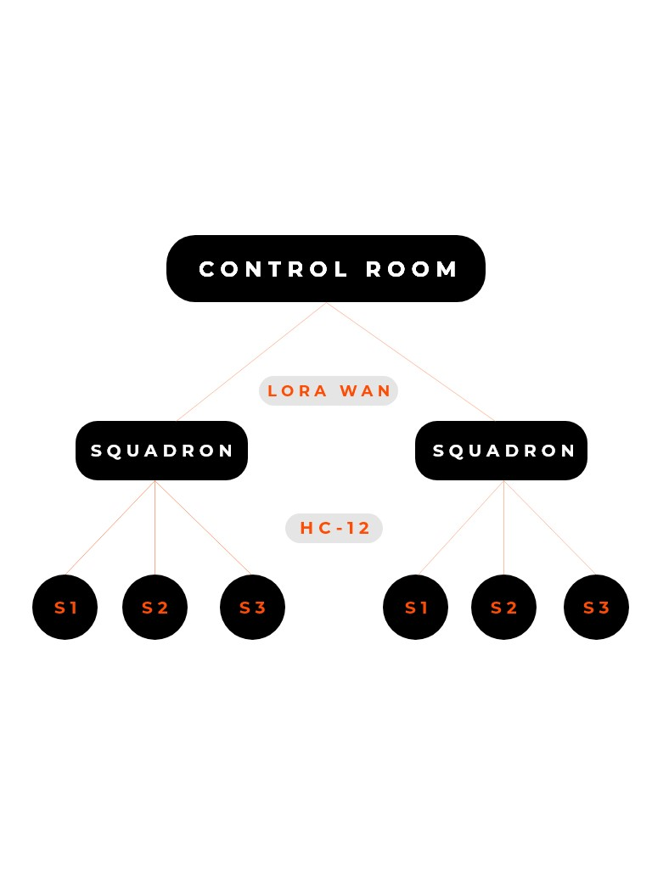

A breif explaination of all the nodes :

4.1.3.1. LEVEL 1. Soldier’s Unit

This unit consists of body area sensor networks such as temperature sensor, heart beat sensor, humidity sensor, vibration sensor, GPS and bomb detector. These sensors are used to sense the health parameters of soldiers, tracking their location and to detect if there has been a bomb explosion nearby by tracing explosive compounds in the environment. The sensed analog signals will be converted into digital signals using analog to digital converter and then compared with the normal conditional signals. If any discrepancy occurs between sensed signals and defined normal signals, then it will be considered as an emergency. The use of a paper bomb detector has also been proposed in this paper to detect the presence of any explosive compound in the atmosphere nearby. The soldier’s unit shall have a ZigBee module that will be used for communication between the soldier and the respective squadron leader.

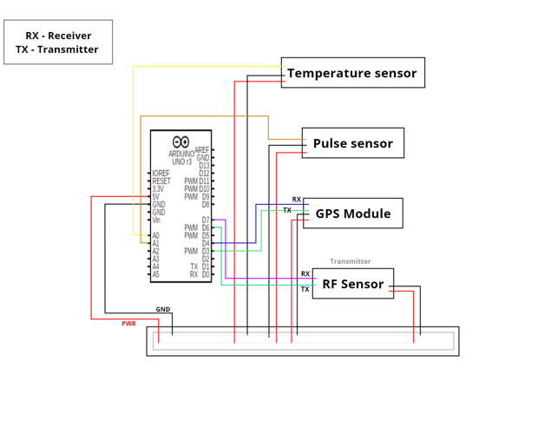
4.1.3.1. LEVEL 1. Soldier’s Unit Working

4.1.3.1. LEVEL 1. Soldier’s Unit Programming
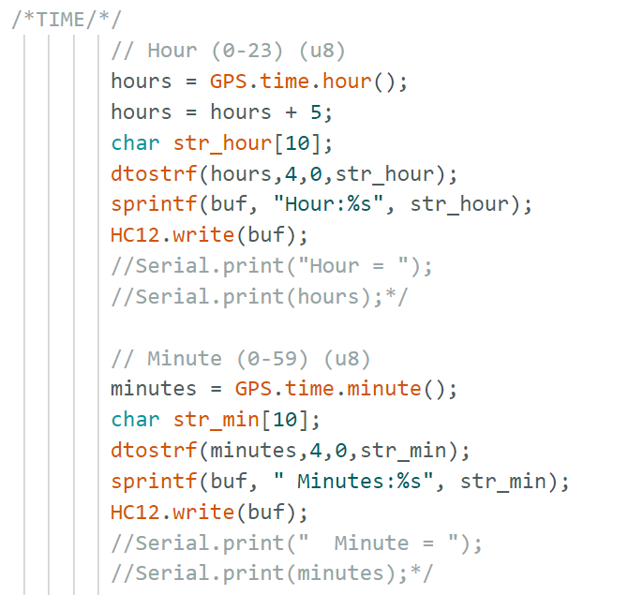
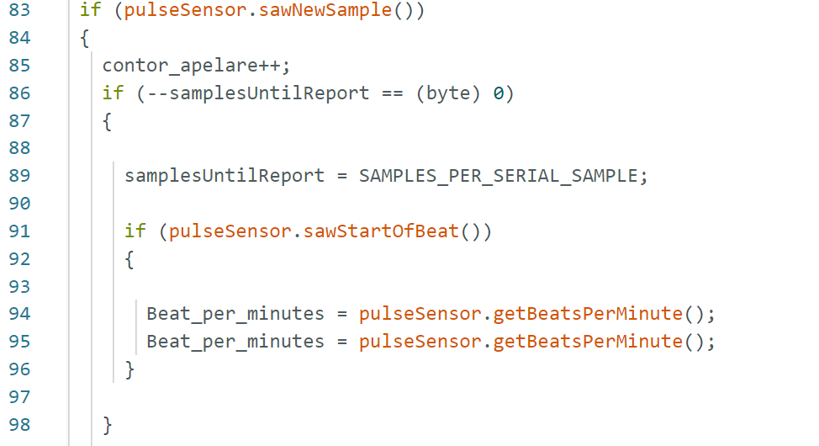

4.1.3.2. LEVEL 2. The Squadron Leader’s Unit or Sub-Master’s Unit

For each and every field operation, there is always an on-field Squadron Leader who is in continuous communication with the control unit. In the proposed methodology, this leader will be equipped with an extra Lora WAN module which will be responsible of transferring data through the LoRa-WAN to the control unit. The sub-master unit will also be equipped with a ZigBee module to collect data from the other soldiers present in the area of operation. The sub-master unit and other soldier units would communicate using the multi-hop protocol. Thus, this sub-master unit acts as the cluster head for each and every squad that goes into the battle. free data storage and analysis of time-stamped numeric or alphanumeric.

4.1.3.3. LEVEL 3. Control Unit

This node includes the wireless LoRa module, where it receives the data of both nodes i.e soldier’s and squadron leaders, from the squadron leader’s node. This node is just about monitoring, storing, and analyzing the received data from the other two node i.e Soldier’s node and the squadron leader’s node.

Additionally, the control unit node is provided with an extra feature, where they can monitor soldier’s directly through the internet using a graphical interface/dashboard. This is possible using the blynk application on the mobile phone available at control unit node, provided the soldier’s module is also connected to the internet.

4.1.3.3. LEVEL 3. Control Unit
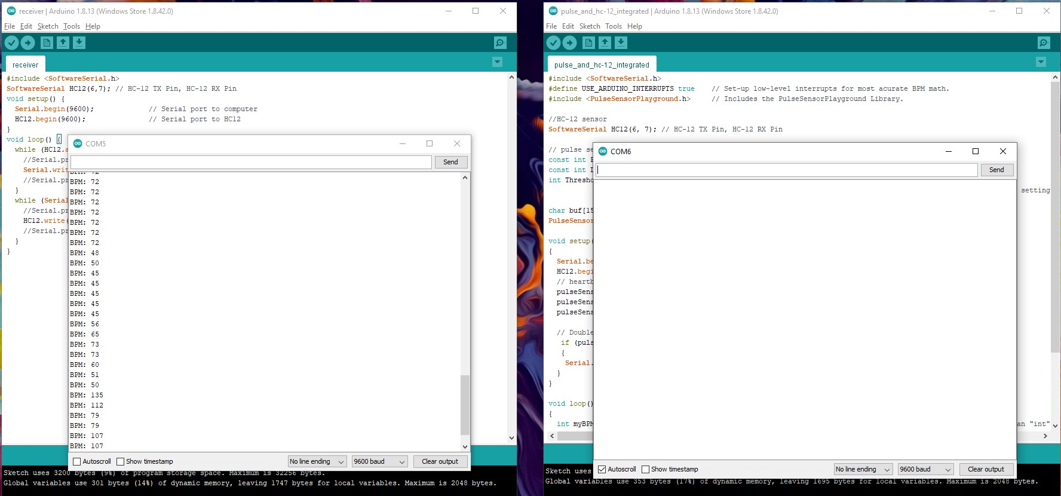
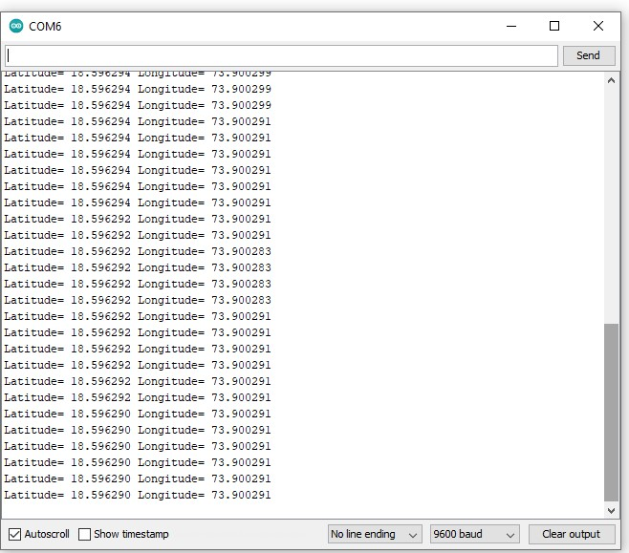
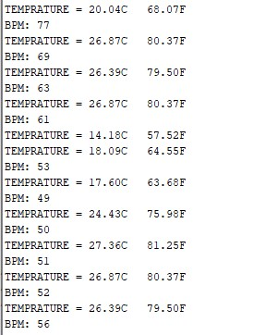

4.1.4. Software Algorithm

From the sensor data collected on cloud like – temperature, humidity, heartbeat sensor insights will be derived using K-Means Clustering. It solves the problem of unsupervised learning as any information or an insight about the relations between different data that we are collecting is not available forehand. From the input data of different sensors, for different actions or events like running, walking, sitting, in case of bombing, injury; each cluster predicts these different events based on the data collected.
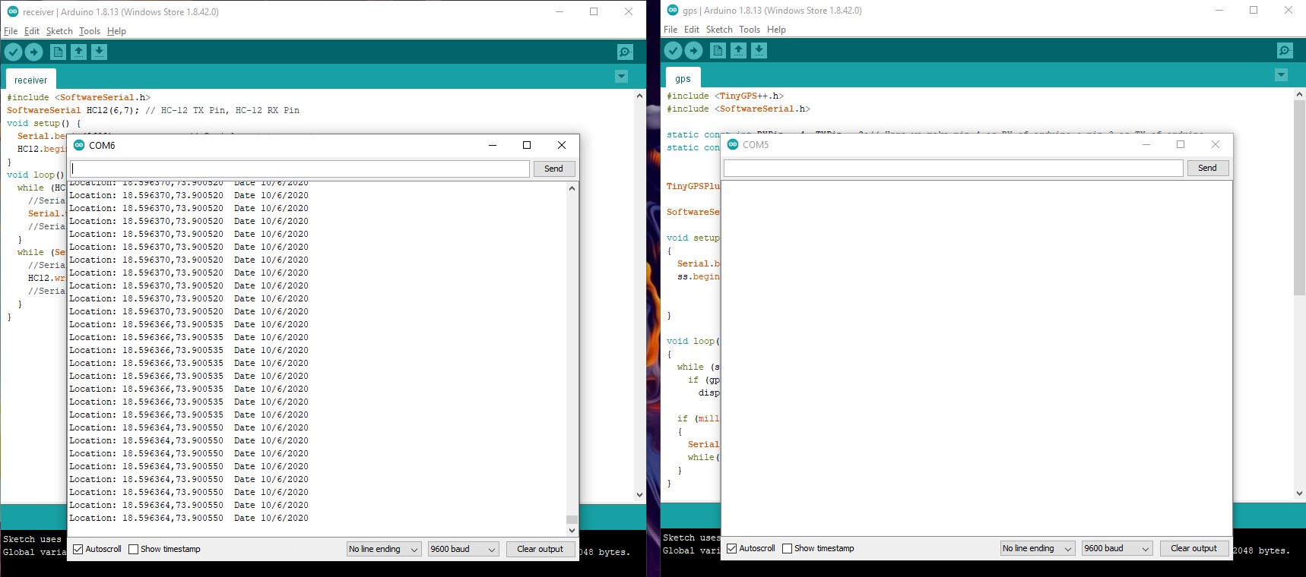
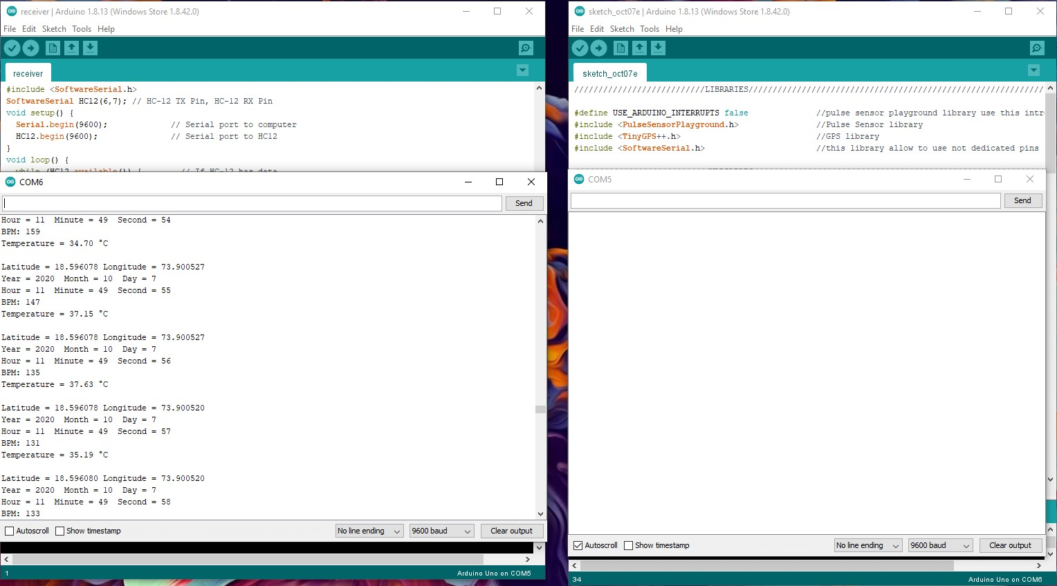

WORKING
The system has two sections, hardware and software. The system consists of 3 nodes i.e Soldier’s node, Squadron leader’s node, and Control unit node. At all the nodes Arduino constantly monitors and records data from the several sensors connected to the system, and communicates with other nodes using wireless modules present in the system.

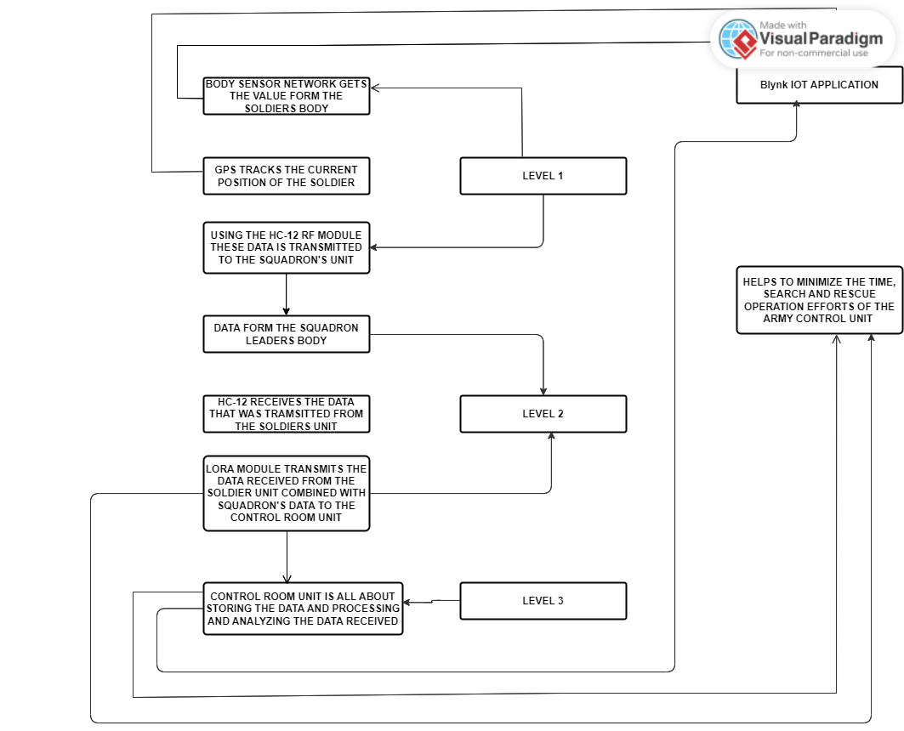
Flow chart

The block diagram below explains how the nodes and all the internal sensors are connected.
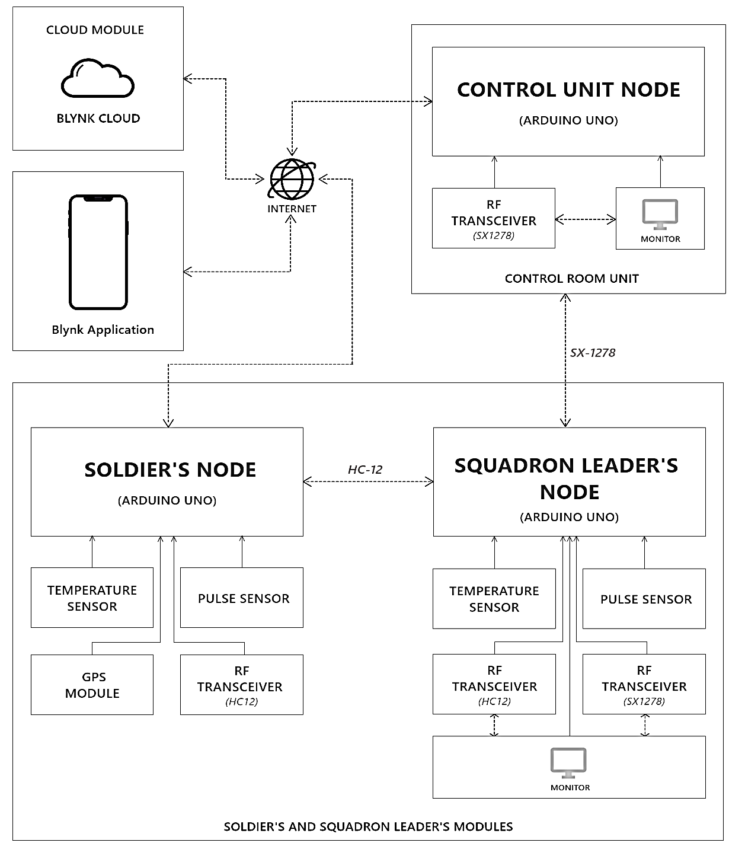

Chapter 5

5.1. Conclusion & Future scope

Algorithm Efficacy Across Diverse Populations: Future studies should encompass a broader range of individuals, spanning various age groups, health conditions, and demographics. Validating the algorithm's performance across diverse populations will enhance its applicability and reliability in real-world scenarios, ensuring that it caters to the unique physiological characteristics and health concerns of different individuals.
Enhanced Security Measures: Incorporating advanced encryption techniques, such as homomorphic encryption or quantum cryptography, will bolster the system's security posture, safeguarding sensitive health data from unauthorized access or malicious attacks. This proactive approach to cybersecurity will mitigate potential vulnerabilities and instill greater confidence in the system's data protection capabilities.
Broader Testing: Conducting extensive field tests in diverse environmental conditions, including extreme temperatures, high altitudes, and adverse weather, will provide valuable insights into the system's robustness and performance under challenging circumstances. Gathering comprehensive user feedback from a larger sample size will further refine the system's usability and effectiveness in real-world military operations.
Integration with Wearable Technology Trends: Exploring emerging wearable sensors and devices, such as smart fabrics, continuous glucose monitors, or environmental sensors, will expand the system's capabilities for monitoring soldiers' health and well-being in real-time. Integrating these advancements will enhance the system's ability to detect and respond to potential health risks or environmental hazards proactively.
Enhanced Data Analytics and Predictive Insights: Adopting advanced data analytics techniques, such as machine learning algorithms or predictive modeling, will unlock deeper insights from the collected health data. Leveraging predictive analytics will enable proactive interventions and personalized healthcare recommendations, ultimately improving soldiers' overall health outcomes and mission readiness.
Augmented Reality (AR) Interfaces: Integrating AR interfaces into the monitoring system will provide soldiers with immersive, real-time visualizations of critical health and location data overlaid onto their surroundings. This augmented situational awareness will empower soldiers to make informed decisions and take decisive actions in dynamic battlefield environments, enhancing mission effectiveness and safety.
Bi-directional Communication and Command Support: Expanding the system's communication capabilities to support bidirectional communication between soldiers and command units will foster greater collaboration and coordination during missions. Implementing features such as voice commands, messaging platforms, and real-time video streaming will facilitate rapid information exchange and decision-making, optimizing mission outcomes.
Environmental Adaptability and Durability: Continuously improving the system's ruggedness and durability to withstand harsh environmental conditions will ensure reliable operation in challenging operational environments. Enhancing resistance to temperature extremes, moisture, and physical impact will enhance the system's longevity and performance, minimizing downtime and maintenance requirements.
Interoperability with Existing Military Systems: Ensuring seamless integration with existing military communication and command systems will enhance interoperability and interoperability. This integration will enable seamless data exchange and collaboration across different military units and platforms, streamlining operational workflows and enhancing situational awareness on the battlefield.
Cybersecurity and Data Privacy: Implementing robust cybersecurity measures, such as end-to-end encryption, multi-factor authentication, and intrusion detection systems, will safeguard sensitive military data from cyber threats and unauthorized access. Prioritizing data privacy through stringent access controls and anonymization techniques will uphold soldiers' confidentiality and trust in the system's security posture.
Scalability and Modular Design: Designing the system with scalability and modularity in mind will facilitate seamless integration of new sensors, communication protocols, and functionalities as technology evolves. Adopting a modular architecture will future-proof the system, enabling agile upgrades and expansions to accommodate emerging requirements and advancements in military technology.
User Experience Optimization: Continuously refining the user interfaces based on feedback from soldiers and commanders will optimize usability and acceptance of the system. Iterative design improvements, usability testing, and incorporating human-centered design principles will enhance user satisfaction and efficiency, fostering greater adoption and engagement with the monitoring system.
Cross-Domain Applications and Civilian Use Cases: Exploring applications beyond military operations, such as emergency response, disaster management, and healthcare monitoring, will broaden the system's impact and relevance. Adapting the technology for civilian use cases will open up new markets and opportunities for collaboration with non-military organizations, facilitating knowledge transfer and innovation across domains.

References

[1] Hock Beng Lim, Di Ma, Bang Wang, Zbigniew Kalbarczyk, Ravishankar K. Iyer, Kenneth L. Watkin (2010) “A Soldier Health Monitoring System for Military Applications” International Conference on Body Sensor Networks, pp: (246-249).

[2] William Walker, A. L. Praveen Aroul, Dinesh Bhatia (2009) “Mobile Health Monitoring Systems” 31st Annual International Conference of the IEEE EMBS, Minneapolis, Minnesota, USA, pp: (5199-5202).

[3] M. Pranav Sailesh, C. Vimal Kumar, B. Cecil, B. M. Mangal Deep, P. Sivraj (2014) “Smart Soldier Assistance using WSN” International Conference on Embedded Systems - (ICES 2014), IEEE, pp: (244-249).

[4] P.S. Kurhe, S.S. Agrawal (2013) “Real Time Tracking and Health Monitoring System of Remote Soldier Using ARM 7”, International Journal of Engineering Trends and Technology, 4(3), pp: (311-315).

[5] Shruti Nikam, Supriya Patil, Prajkta Powar, V. S. Bendre (2013) “GPS Based Soldier Tracking and Health Indication System” International Journal of Advanced Research in Electrical, Electronics and Instrumentation Engineering, 2(3), pp: (1082-1088).

[6] Prof. Pravin Wararkar, Sawan Mahajan, Ashu Mahajan, Arijit Banerjee, Anchal Madankar, Ashish Sontakke (2013) “Soldier Tracking and Health Monitoring System” The International Journal of Computer Science & Applications, 2(02), pp: (81-86).

[7] Govindaraj A., Dr. S. Sindhuja Banu (2013) “GPS Based Soldier Tracking and Health Indication System with Environmental Analysis”, International Journal of Enhanced Research in Science Technology & Engineering, 2(12), pp: (46-52).

[8] Palve Pramod, “GPS Based Advanced Soldier Tracking With Emergency Messages & Communication System” (2014) International Journal of Advance Research in Computer Science and Management Studies, 2(6), pp: (25-32).

[9] Mr. Rajdeep Limbu, Prof. V. V. Kale (2014) “GPS Based Soldier Tracking and Health Monitoring System” International Journal for Technological Research in Engineering, 1(12), pp: (1485-1488).

[10] Rubina.A.Shaikh (2012) “Real Time Health Monitoring System of Remote Patient Using Arm7” International Journal of Instrumentation, Control and Automation, 1(3-4), pp: (102-105).

[11] Ekta Madhyan, Mahesh Kadam (2014) “A Unique Health Care Monitoring System Using Sensors and ZigBee Technology” International Journal of Advanced Research in Computer Science and Software Engineering, 4(6), pp: (501-509).

[12] Dr. S. S. Riaz Ahamed (2009) “The Role of ZigBee Technology in Future Data Communication System” Journal of Theoretical and Applied Information Technology, 5(2), pp: (129-135).

[13] Nisha Ashok Somani, Yash Patel (2012) “ZigBee: A Low Power Wireless Technology for Industrial Applications” International Journal of Control Theory and Computer Modeling, 2(3), pp: (27-33).

[14] P. Rohitha, P. Ranjeet Kumar, Prof. N. Adinarayana, Prof. T. Venkat Narayana Rao (2012) “Wireless Networking through ZigBee Technology” International Journal of Advanced Research in Computer Science and Software Engineering, 2(7) , pp: (49-54).

[15] Dineshkumar Jaiswar, Sanjna S. Repal (2015) “Real Time Tracking and Health Monitoring of Soldiers using ZigBee Technology: a Survey” International Journal of Innovative Research in Science, Engineering and Technology, 4(7).

[16] Shruti Nikam, Supriya Patil, Prajkta Powar, V.S.Bendre (2013) “GPS based Soldier Tracking and Health Indication System” International Journal of Advanced Research in Electrical, Electronics and Instrumentation Engineering, 2(3).

[17] Akshita V. Armarkar, Deepika J. Punekar, Mrunali V. Kapse, Sweta Kumari, Jayshree A. Shelke (2017) “Soldier Health and Position Tracking System” IJESC, 7(3).

[18] Afef Mdhaffar, Tarak Chaari, Kaouthar Larbi, Mohamed Jmaiel and Bernd Freisleben (2017) “IoT-based Health Monitoring via LoRaWAN” IEEE EUROCON.

[19] M.V.N.R. Pavan Kumar, Ghadge Rasika Vijay, Patil Vidya Adhikrao, Bobade Sonali Vijaykumar (2014) “Health Monitoring and Tracking of Soldier Using GPS” International Journal of Research in Advent Technology, 2(4).

[20] R. Archana, S. Indira (2013) “Soldier Monitoring and Health Indication System” International Journal of Science and Research (IJSR)

[21] Hock Beng Lim, Di Ma, Bang Wang, Zbigniew Kalbarczyk, Ravishankar K. Ayer, Kenneth L. Watkin (2010) “A Soldier Health Monitoring System for Military Applications” International Conference on Body Sensor Networks, pp: (246-249)

[22] William Walker, A. L. Praveen Aroul, Dinesh Bhatia (2009) “Mobile Health Monitoring Systems” 31st Annual International Conference of the IEEE EMBS, Minneapolis, Minnesota, USA, pp: (5199-5202).

[23] M. Parma Salish, C. Vimal Kumar, B. Cecil, B. M. Mangal Deep, P. Sivraj (2014) “Smart Soldier Assistance using WSN” International Conference on Embedded Systems - (ICES 2014), IEEE, pp: (244-249).

[24] P.S. Kruse, S.S. Agrawal (2013) “Real Time Tracking and Health Monitoring System of Remote Soldier Using ARM 7”, International Journal of Engineering Trends and Technology, 4(3), pp: (311-315).

[25] Shruti Nikam, Supriya Patil, Prajkta Powar, V. S. Bendre (2013) “GPS Based Soldier Tracking and Health Indication System” International Journal of Advanced Research in Electrical, Electronics and Instrumentation Engineering, 2(3), pp: (1082-1088)

[26] Prof. Pravin Wararkar, Sawan Mahajan, Ashu Mahajan, Arijit Banerjee, Anchal Madankar, Ashish Sontakke (2013) “Soldier Tracking and Health Monitoring System” The International Journal of Computer Science & Applications, 2(02), pp: (81-86)

[27] Govindaraj A., Dr. S. Sindhuja Banu (2013) “GPS Based Soldier Tracking and Health Indication System with Environmental Analysis”, International Journal of Enhanced Research in Science Technology & Engineering, 2(12), pp: (46-52).

- 11. Appendices

- 12. List of Publications

